TPP SystmOne – Word Letter Templates
You will need to have Template Administrator Access Rights to be able to access and edit documents in TPP SystmOne.

- Log in to TPP SystmOne in the usual way.

- Navigate to Setup > Referrals & Letters > Word Letter Templates as below.

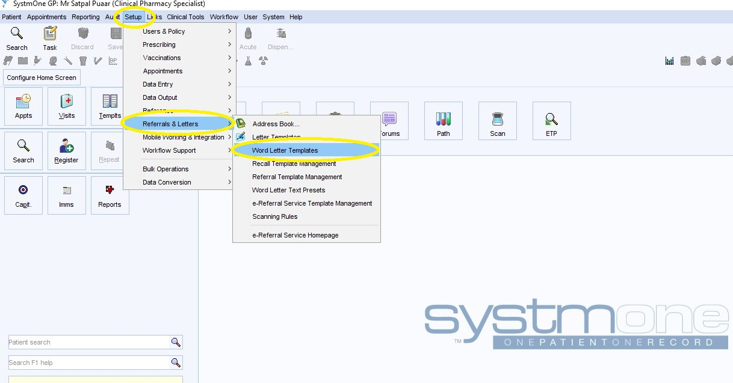

To access all versions of the Pan-London Symptom Control MAAR chart type ‘MAAR’ into the search bar as shown below and click the search button:

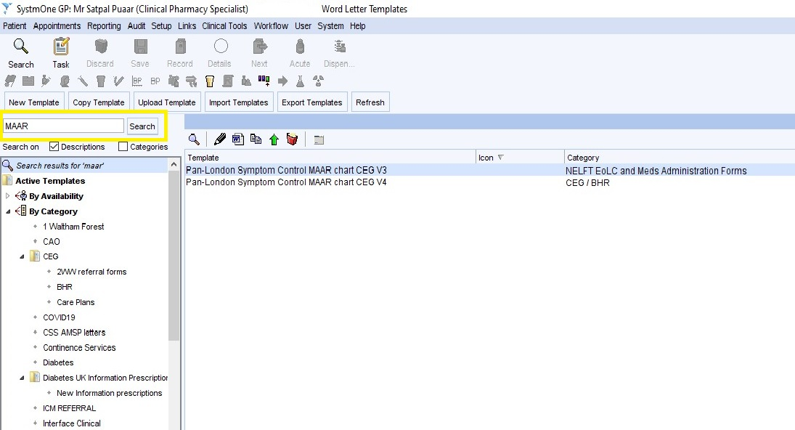
The Pan-London Symptom Control MAAR chart CEG V4 is the most recent version and will now supersede all older versions.
To remove older versions of the Pan-London Symptom Control MAAR chart follow steps below:
- navigate to the template > right-click mouse > select delete

